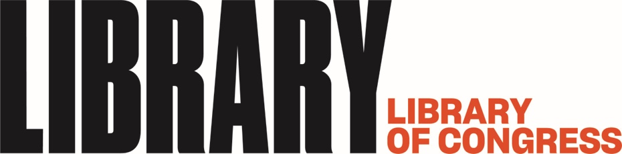

February 4, 2019

Media contact: Sheryl Cannady, (202) 707-6456, scannady@loc.gov
Public contact: Fenella France, (202) 707-5525, frfr@loc.gov

Library Receives Major Grant From The Andrew W. Mellon Foundation
Project Will Support Development of a National Book Preservation Plan

The Library of Congress announced today that it has received a $540,000 grant from The Andrew W. Mellon Foundation to evaluate the physical health of the national collection of books in American research libraries and to guide their archive retention and preservation decisions. Since there currently is no objective formula to assess the condition of millions of books in the custody of the nation’s libraries, this scientific study will help inform best practices and provide a baseline for libraries to analyze their print collections based on established scientific guidelines.
This is the first effort of its kind to lay the scientific groundwork for the development of a national effort to preserve the corpus of books held in American libraries. Entitled “Assessing the Physical Condition of the National Collection,” the 40-month grant project through the Scholarly Communication Program will compare the physical, chemical and optical characteristics of a representative sample of bibliographically identical books across five large research libraries in distinct regions of the country to quantify and objectively assess the condition of these volumes. The five participating institutions are Arizona State University, Cornell University, University of Colorado at Boulder, University of Miami and University of Washington.
The study will help provide a comparable and reliable decision-making method for libraries to follow in deciding what books and how many should be kept in the national collective. The collected data will build a knowledge base for how materials naturally age and decompose, provide a rich set of data about books as artifacts and lead to a stronger predictive model for the condition of books. One objective of the project is also to develop simpler testing tools that could be used on-site in library book stacks.
“Contemporary scholarship crosses boundaries of format, institution, and discipline,” said Jacob Nadal, the Library’s director for Preservation. “Libraries are enabling this through sophisticated partnerships and services that draw on print and digital resources for the distinct qualities that each format offers. This project unites the most current library science with our long history of cooperation to help libraries advance our core professional goals: providing access to research materials and preserving the published record in its original forms.”
The Library of Congress is well suited to conduct this scientific research because of its extensive preservation programs and research laboratories. The research work will take place in the Preservation Research and Testing Division (PRTD) at the Library of Congress and build on the institution’s extensive research into noninvasive and microsampling analytic methods. These techniques enable large scientific analysis of library materials to be conducted at a speed and scale that were not practical before.
“Until we can understand and compare the actual condition of the printed volumes in America, we won’t know how to ensure these are available for future generations,” said Fenella G. France, PRTD chief and the project’s principal investigator. “We may be moving to an increasingly digital world, but so much of our history is retained on the printed record and we must preserve this.”
PRTD will host two researchers for three years, each of whom will complete the analysis of 500 of the same volumes from the five selected American research libraries, totaling 2500 volumes. The Library will convene an expert advisory body to review the work in process and schedule conferences periodically to report the project’s progress. The study’s findings will be shared nationally at a major event in 2022.
The Library of Congress has one of the most extensive library and archival preservation programs in the world. The Library’s Preservation Directorate staff evaluates, manages and responds to the challenges of ensuring access to the Library’s collection of more than 167 million items in a diverse and expanding range of formats. The Library’s Preservation Research and Testing Division has been a world leader in developing preservation research to prevent degradation and extend the life of collections. The chemical, mechanical and optical properties labs have developed many innovative research applications and collaborate with colleagues in academia, cultural heritage, science and forensic laboratories.
The Library of Congress is the world’s largest library, offering access to the creative record of the United States — and extensive materials from around the world — both on-site and online. It is the main research arm of the U.S. Congress and the home of the U.S. Copyright Office. Explore collections, reference services and other programs and plan a visit at loc.gov; access the official site for U.S. federal legislative information at congress.gov; and register creative works of authorship at copyright.gov.

# # #

PR 19-011
02/04/19
ISSN 0731-3527

